Newtyle
Primary School and Pre- School
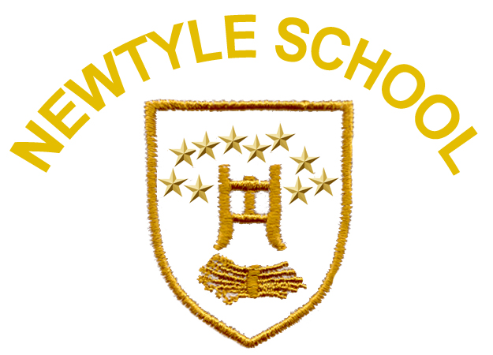
Health & Wellbeing Policy

Work Together To Be The Best We Can Be

Introduction

Learning in health and wellbeing ensures that children and young people develop the knowledge and understanding, skills, capabilities and attributes which they need for health and wellbeing now and in the future.

“Learning through health and wellbeing promotes confidence, independent thinking and positive attitudes and dispositions. Because of this, it is the responsibility of every teacher to contribute to learning and development in this area.”
Building the Curriculum 1, Scottish Executive 2006

Within Curriculum for Excellence, health and wellbeing is defined as

“The knowledge and understanding, skills, capabilities, and attributes needed for mental, emotional, social and physical wellbeing now and in the future”

Curriculum for Excellence: Health and Wellbeing, Scottish Government, 2009

Learning through health and wellbeing enables children and young people to:

- make informed decisions in order to improve their mental, emotional, social and physical wellbeing
- experience challenge and enjoyment
- experience positive aspects of healthy living and activity for themselves
- apply their mental, emotional, social and physical skills to pursue a healthy lifestyle
- make a successful move to the next stage of education or work
- for some, open up opportunities to perform at high levels in sport or pursue careers in health or leisure industries
- establish a pattern of health and wellbeing which will be sustained into adult life, and which will help to promote the health and wellbeing of the next generation of Scottish children

Rationale

“Children and young people should feel happy, safe, respected, and included in the
school environment and all staff should be proactive in promoting this. Good health and wellbeing is central to effective learning and preparation for successful independent living.”

Building the Curriculum 1, Scottish Executive 2006

The importance of ensuring that young people pursue a healthy lifestyle cannot be underestimated. Newtyle Primary School and Pre-School recognises that improving skills in mental, emotional, social and physical wellbeing contributes not only to success in education and the life chances of pupils as they grow up, but also impacts upon the success of Scotland as a nation.

Health and wellbeing across learning is the responsibility of all staff in Newtyle Primary School and Pre-school. Working with partners, we take a holistic approach to promoting health and wellbeing, taking account of the stage of growth, development and maturity of each pupil, and the social and community context. Curriculum for Excellence provides the context in which this can be addressed. Therefore, health and wellbeing, in addition to numeracy and literacy, is one of three cross-cutting themes which are the responsibility of all school staff in Newtyle.

Curriculum for Excellence states all practitioners must be aware of his or her responsibilities within health and wellbeing and support children and young people to ensure that they are –

Safe : Healthy : Achieving : Nurtured : Active : Respected : Responsible : Included
(SHANARRI)

The shared vision and common goal for health and wellbeing

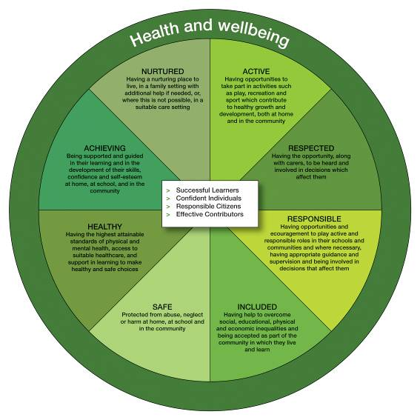

Aims of Policy

- Provide an effective framework to inform the planning of high quality health and wellbeing learning experiences in Newtyle Primary School and Pre-school

- Ensure all staff understand what health and wellbeing is and of its fundamental importance in equipping children and young people to live a healthy and happy life in the 21st Century

- Ensure that all pupils are provided with maximum opportunities to acquire knowledge, understanding and skills which they can apply effectively and with confidence to help them live a happy and healthy lifestyle

- Promote effective progression and continuity at all stages and across areas of transition to ensure a seamless, coherent and relevant health and wellbeing curriculum for all pupils

- Ensure that everyone within our school community shares the responsibility for creating a positive ethos and climate of respect and trust – one in which everyone can make a positive contribution to the wellbeing of each individual within the school and the wider community

- Increase staff skills and confidence by ensuring that all school staff understand their role and responsibility for health and wellbeing within the context of ‘Getting it Right in Angus’

‘Getting It Right in Angus’ pledges that education staff work together with parents or carers, and the child or young person and all relevant agencies to ensure that the universal needs of children and young people are met

The ‘My World Triangle’ illustrates the indicators of wellbeing that are being promoted within the ‘Getting it Right’ approach:

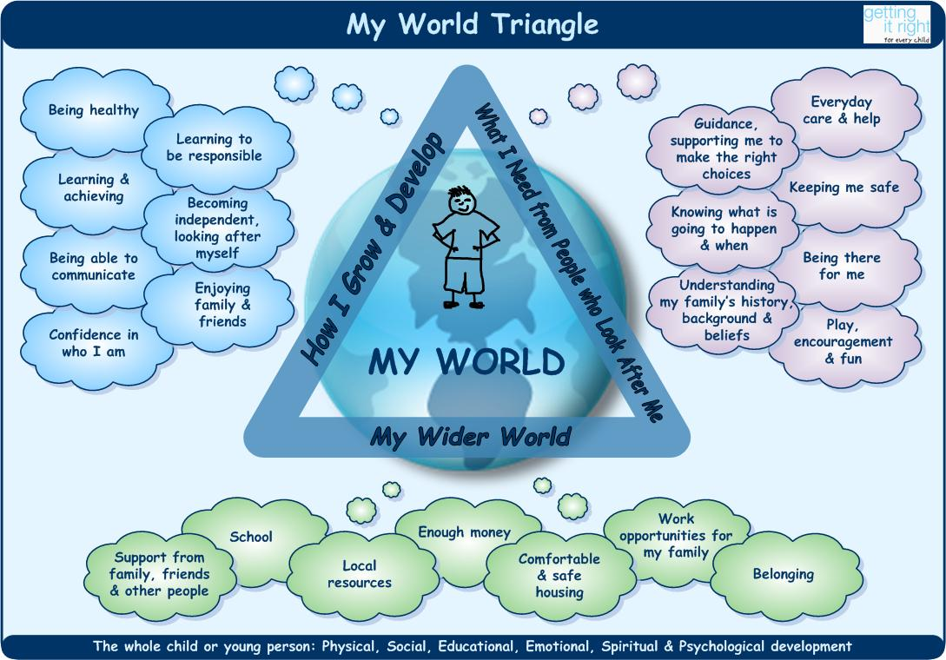

Curriculum

The Curriculum for Excellence health and wellbeing experiences and outcomes promote effective learning and teaching methodologies which stimulate the interest of young people, promote confidence, independent thinking and positive attitudes.

Health promoting schools activities are fundamental to our curriculum:

These health promoting school initiatives will ensure that all children can develop as successful learners, confident individuals, responsible citizens and effective contributors.

All children will be helped to develop as successful learners who can:

- understand and develop the physical, social and emotional factors that influence their health and wellbeing
- acquire a wide range of physical skills and abilities
- learn the social and emotional skills which can help them to embrace change and challenge
- develop emotional resilience in dealing with competitive and challenging situations
- express themselves creatively as individuals and as part of a group
- develop their interests and preferences
- set and review personal goals for achievement in their lifestyle, learning and development

All children will be helped to develop as confident individuals who can:

- develop the capacity to live a full life
- deal with the unexpected and cope with adversity
- develop resilience, fitness and confidence
- sustain personal relationships
- develop skills which will enable them to live independently
- recognise and deal with the many different pressures in life
- identify when they need support
- find appropriate sources of information and make informed choices to live a healthy, fulfilled life

All children will be helped to develop as responsible citizens who can:

- learn to respect and value other people
- develop an understanding of their beliefs and feelings
- develop positive relationships, promote equality and fairness and counter discrimination
- develop an awareness of healthy diet, activity, positive relationships and risks to health
- establish important foundations for their future life, including parenting
- develop an understanding of how their actions and decisions are affected by and affect others
- recognise how important it is to behave in ways that can have a positive effect on other people and the environment

All children will be helped to develop as effective contributors who can:

- engage positively in experiences that are fun, enjoyable, exciting and challenging in a variety of settings
- make positive contributions to the wider life and health of the school and community
- explore different options for life beyond school
- access support to help them make successful transitions into work, education or training

Health promoting initiatives
We were re-accredited as a health promoting school in November 2011. The school and pre-school provides stimulating challenges for all pupils. These include:

- Participation in a variety of school sporting activities
- Playground games and equipment
- Outdoor play for nursery and primaries 1 to 7
- Dance, music, drama, art and environmental activities
- Annual Outdoor Cluster Residential trip for Primary 7 (Dalguise)
- Extra-curricular activities (e.g. Netball, Hockey, Scottish Country Dancing)
- Cool in School P1-7 Programme promoting positive social behaviours and resilience to cope with life
- All aspects of Health and wellbeing as part of the curriculum – using OTWL to plan and evaluate experiences and learning in H & WB
- Golden Time
- Effective programmes of transition between playgroup and nursery, nursery and Primary 1 and Primary 7 into secondary school
- Vertical Pupil Leadership Groups: Eco Committee, Health Committee, Literacy Committee and Pupil Council
- Free fruit for P1-3 three times a week
- Encourage pupils to drink water in class; access to fresh drinking water in school
- Involvement with external agencies to help pupils, parents and staff in activities and information available which would promote a healthy and active lifestyle e.g. close links with PC Bell; School Nurse
- Health Week involving a range of partner agencies to support and extend children’s experiences in health and wellbeing
- Supporting parents through workshops and meetings e.g. Cool in School curriculum afternoon, Curriculum for Excellence Curriculum Evening
- Enterprise activities e.g. Preparing items to sell at Christmas Fayre, organising events for our community
- Annual communication with parents on sex education programme
- Healthy snack in the pre-school
- Buddying, playground monitors, lunch monitors and line leaders
- Access to Active Primary School Co-ordinator – regularly taster sessions organised in school e.g. rugby, kick boxing, football
- Sample lunch for parents of new intake
- Anti-bullying awareness and strategies; staff, parent and pupil leaflets
- Worry/suggestion box for all pupils
- Regular consultation with pupils regarding improving the school – display responses and share how we are taking suggestions forward
- House/Vice Captain System
- Health snack and helping with planning and preparation of this in pre-school
- Important life skills developed in pre-school and school e.g. hand washing, tooth brushing and good hygiene
- Bug box hand washing
- Pre-school tooth brushing

We are health promoting because we:
- actively promote self-esteem of the whole school community
- develop good relations within the school
- develop good relations with home and community
- provide a wide range of stimulating challenges for all pupils
- use every opportunity to improve the physical environment of the school
- plan and deliver a coherent curriculum based on OTWL health and wellbeing learning programme
- actively promote the health and well-being of all school staff
- develop staff awareness of their professional roles in health-related issues and have a whole-school approach to professional development in this area
- acknowledge school nutrition reflects and supports the healthy school ethos
- activate expertise of specialist services in the community to support health promotion

Learning and teaching

Planning

Staff use Angus Council’s electronic planning tool ‘On Track With Learning’ to support medium term planning in all curricular areas, including health and wellbeing. The tool is based on the Curriculum for Excellence Experiences and Outcomes, focuses on subject knowledge and skills development and embraces the seven principles of curriculum design: challenge and enjoyment, breadth, progression, depth, personalisation and choice, coherence, relevance.

- Active learning opportunities are planned for to provide Challenge and Enjoyment.
- Coverage charts on OTWL and annual overviews are used to track and plan for Breadth of learning to ensure all children experience all experiences and outcomes at each level. Experiences and outcomes are organised into the following sections:
  - Mental, emotional, social and physical wellbeing
  - Planning for choices and changes
  - Physical education, physical activity and sport
  - Food and health
  - Substance Misuse
  - Relationships, sexual health and parenthood
Many of the experiences and outcomes span two or more levels; some are written to span from early to fourth because they are applicable throughout life. All of these are revisited regularly in ways which take account of the stage of development and understanding of each child and realistic for them.

- Planning builds on prior knowledge and experience to ensure Progression. Teachers track and evaluate pupils’ progress using the OTWL planning tool and use this information to inform future learning.
- Pupils are given frequent opportunities to revisit Experiences and Outcomes and apply previously learned knowledge and skills in new and unfamiliar contexts, hence promoting depth of understanding.
- At all stages differentiation is provided through choice of resources and organisation structures such as cooperative learning, flexible ability groups depending on the task; and additional input, support and challenge. This helps to ensure personalisation of learning. We also provide personalisation and choice of learning in P1-7 by encouraging all children to set individual learning targets in health and wellbeing every term. These are located in home/school learning journals and are shared with parents every term.
- Clear links are promoted between health and wellbeing and other subject areas to draw different strands of learning together and provide Coherence. This is identified in project (contextualized) medium term plans.
- Every opportunity is taken to link learning in health and wellbeing to real contexts. This helps pupils to see the relevance of health and wellbeing to their daily lives.
Medium term plans are retained within the OTWL planning tool. A curriculum leaflet that includes planned learning is displayed on the Class Learning Wall. This is updated every term. Medium term planning is discussed every term with the Head teacher and feedback is provided.
Medium term plans are broken down into learning intentions which then inform short term planning. This is undertaken on a weekly/daily basis. The weekly/daily planner outlines learning outcomes, success criteria and resources to be used. Short term plans are located within the OTWL planning tool. Staff regularly evaluate weekly/daily plans and reflect on success, pace and challenge to inform next steps in learning and teaching.

Learning and teaching activities draw upon a skilful mix of approaches in the pre-school and primary stages including:
- Cooperative and independent learning
- Active learning with opportunities to discuss, observe, explore, investigate, experiment and play
- Regular opportunities to discuss, communicate and explain thinking to develop learning skills
- Contextualised learning linked to real life context or a context that is familiar to pupils’ experiences
- Appropriate and effective use of technology
- Assessment is for Learning approaches such as effective questioning, sharing of outcomes, self and peer assessment

Resources

A variety of resources should be used to support active learning and teaching methodologies. All health resources are located in classrooms or in the GP Room on the shelving units. The Cool in School programme is used at all Early, First and Second stages. Commercialised schemes such as Prim Ed Health books are not used to drive learning but are used as a tool to support delivery of lessons and activities.

Assessment/Retention of Evidence

Staff are trained in Assessment is for Learning approaches and this is regularly revisited to develop a range of approaches and encourage effective practice.
The principles of Curriculum for Excellence mean that progress is defined in terms of application, breadth and challenge of achievement at the level for each stage. To ensure that children become confident and secure in their health and wellbeing learning, teachers plan opportunities for children to demonstrate their learning in both familiar and unfamiliar contexts. Effective assessment informs next steps in learning as well as reassurance that children have achieved the skills, attributes and knowledge required to demonstrate confidence within a level.
Assessment will be undertaken in a variety of ways and different forms of evidence will be gathered:

- Ongoing evaluations of progress by linking back to learning outcomes set at planning stages on OTWL tool
- Ongoing use of formative assessment strategies during lessons to give effective feedback and monitor pupil understanding This will inform changes in daily/weekly plans to accommodate changes in pace of learning.
- Use of peer/self assessment by pupils
- Exemplification of learning and understanding included on class learning wall and in individual home school learning journals. This should include written examples and photographs of practical learning. Home school learning journals are updated every term to demonstrate ongoing progress.
- Documenting learning approaches used in Pre-School stages through the use of Wiggly Books. These include tracking of learning and identification of next steps.
- Recognition will be given to pupil achievements within and beyond school. Many such achievements contribute to our local community, raise ethos within the school and promote positive attitudes and confident individuals. Examples of these achievements are recorded in home/school learning journals in outside/wider achievement section and in our whole school successes and achievements book.

Partnership Working
We have a strong commitment to partnership working. Through this we actively seek the views of pupils, staff, parents and the wider community.

Support for pupils
We have a number of mechanisms in school for supporting pupils: Pupil Council, Worry/Suggestion box, Playground Monitors, Buddying, communication with parents, and awareness of all staff to enable them to deal with various difficulties - social, physical and medical. Staff understand procedures for dealing with discipline and bullying type behaviours taking into account the needs and particular problems of the individual child. All staff are informed of ongoing physical or psychological necessities for individuals to ensure a smooth path for all.

Support for staff

Staff can access work related information e.g. on Stress Management, Occupational Health, Health and Safety etc. through Personnel Services on the Angus Council ‘ intranet’ site. The Head Teacher will, in consultation with staff, identify and address any staff development issues which may be required to deliver the Health education programme.

Links with other agencies
We actively seek the expertise of other specialist agencies, for example Health Visitors, Health Promotion Department, NHS, Active Schools Co-ordinators, Social Work, School and Family Support and Psychological Services to support health promotion at the school.

Monitoring and Evaluation

The head teacher will monitor the progress in health and wellbeing and the delivery of the curriculum by:
- Having planning discussion meetings every term to discuss planned learning, coverage of the curriculum and progress of pupils
- Monitoring health and wellbeing jotters/workbooks/home school journals, and discussing learning and teaching with selected focus groups of pupils
- Formal observations of health and wellbeing lessons and learning walls
- Informal visits to each class during a health and wellbeing lesson
- Collated worry and suggestion slips
- General observation of playground and classroom behaviour
- Registers including information regarding children that take part in extra curricular clubs and after school activities
- Carrying out regular audits to review school’s progress against national standards

Equal Opportunities

Newtyle Pre-School and Primary School aims to provide equal opportunities for all pupils irrespective of ability, gender and cultural background. We strive to enable each child to maximise his/her potential.

Authorisation of this policy
This policy has been agreed by all staff and a focus group of pupils and parents.
Review
This policy will be reviewed in January 2015.

